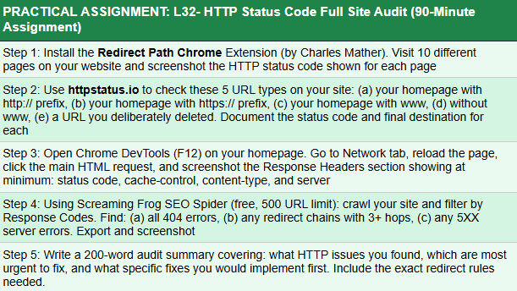
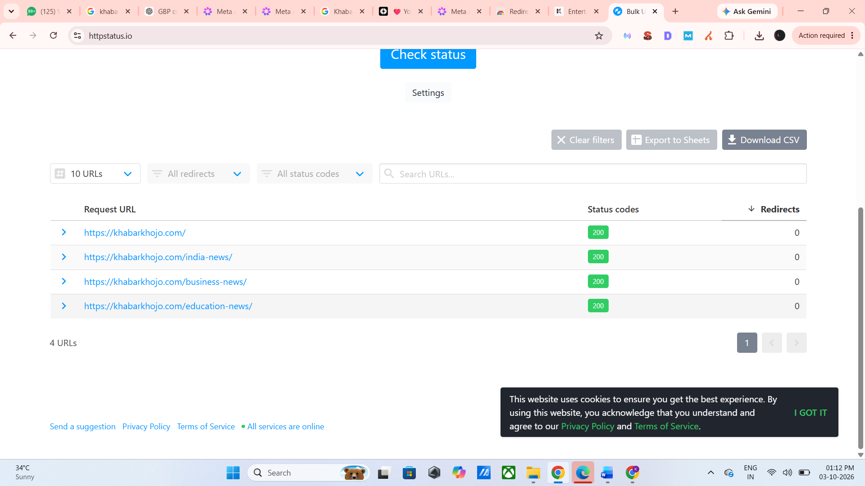

KhabarKhojo was audited for HTTP status codes. The main website pages are returning 200 OK, which indicates that the pages are accessible and working properly. HTTPS is being used as the preferred version of the website. The Screaming Frog crawl was partially completed, but its crawl limit was reached, so complete full-site data could not be collected. Therefore, the available Screaming Frog data was reviewed, but a complete analysis of all 404, 3XX redirect, redirect-chain, and 5XX URLs could not be performed. The remaining data can be checked once the crawl limit is available again.

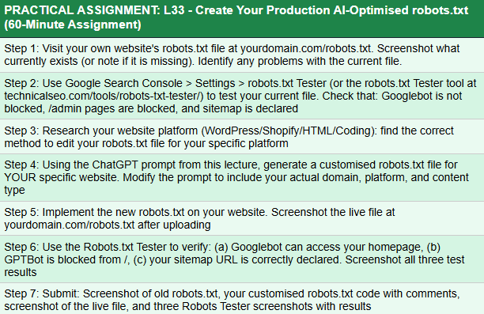
I reviewed the existing robots.txt file and identified a few areas that may need correction. However, I have not made any changes to the live robots.txt file yet. I will make the required changes under my Sir’s guidance to avoid affecting the website’s crawling and indexing.
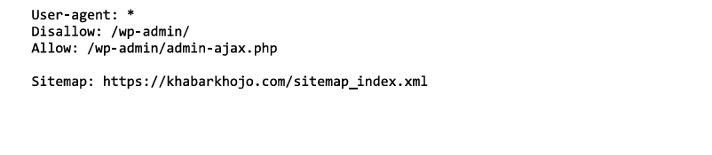
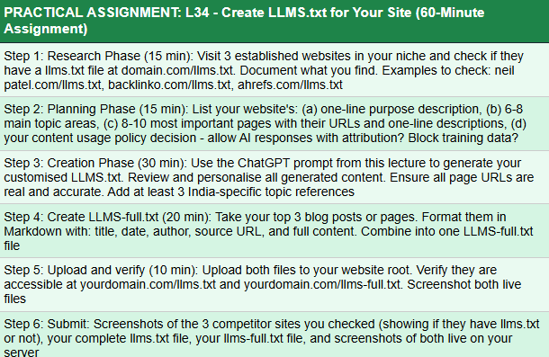
I reviewed the LLMs.txt setup for KhabarKhojo and confirmed that AI/LLM access is currently allowed. However, I have not made any changes to the existing settings or files. Any required changes will be made after discussing them with my Sir and taking his guidance.

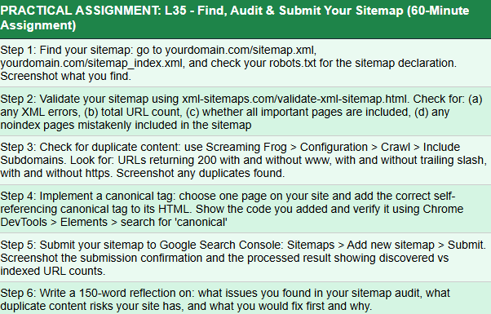
Robots.txt
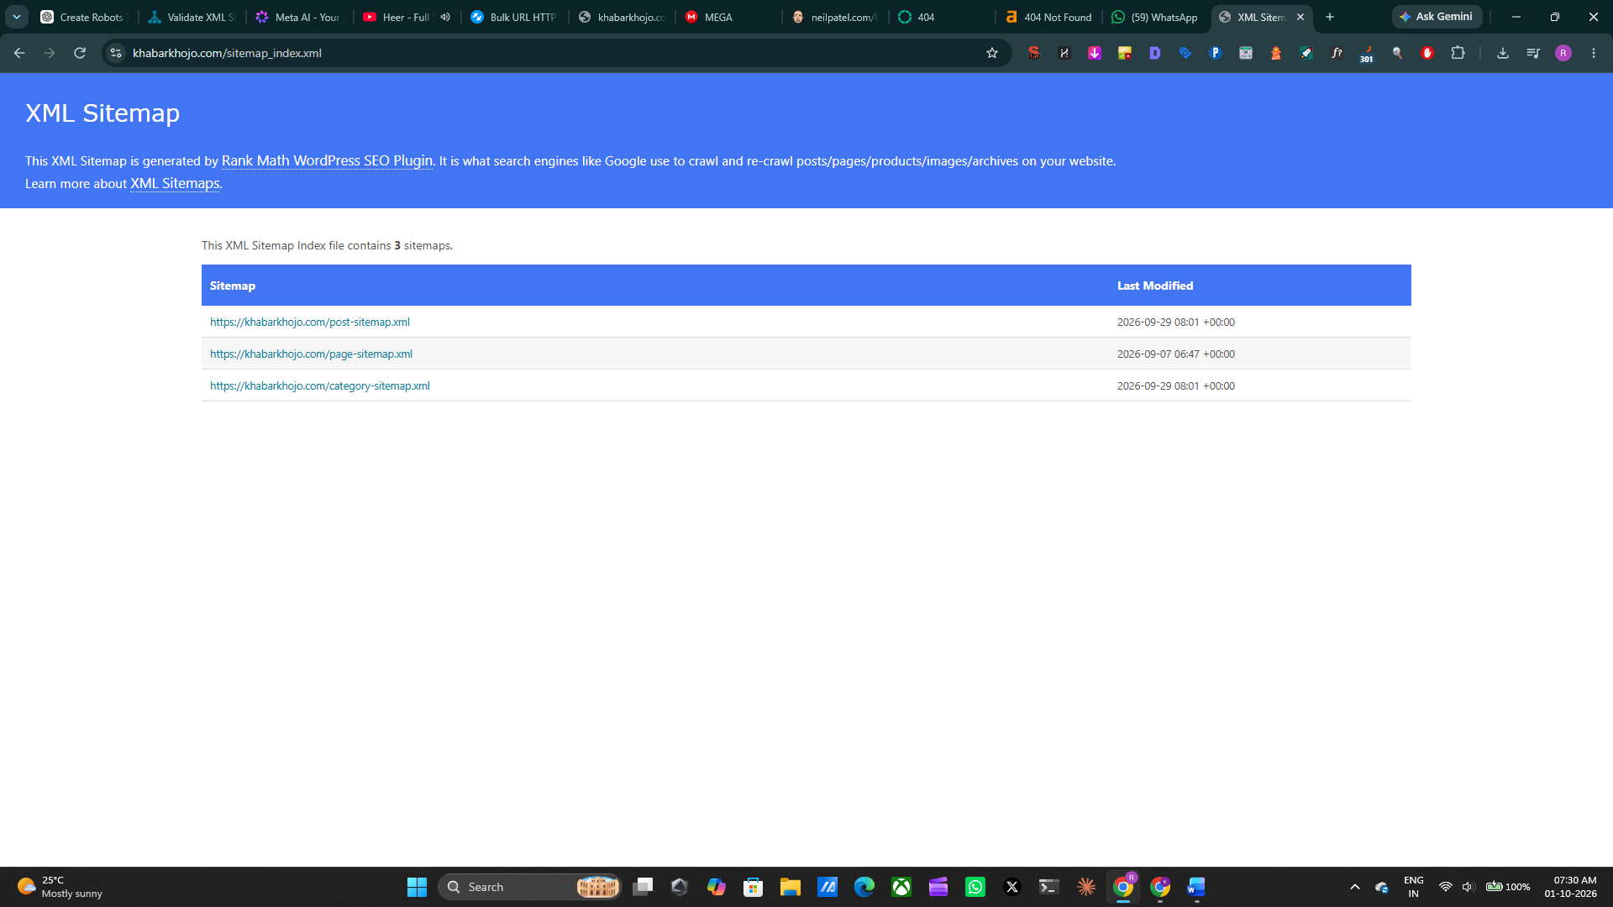

Sitemap
The Khabar Khojo sitemap was already created, so I reviewed its structure, URL coverage, robots.txt declaration, and Google Search Console status. I also checked HTTP/HTTPS and www/non-www variations for duplicate-content risks. No changes were made to the existing sitemap. Any required changes will be made after taking guidance from my Sir.
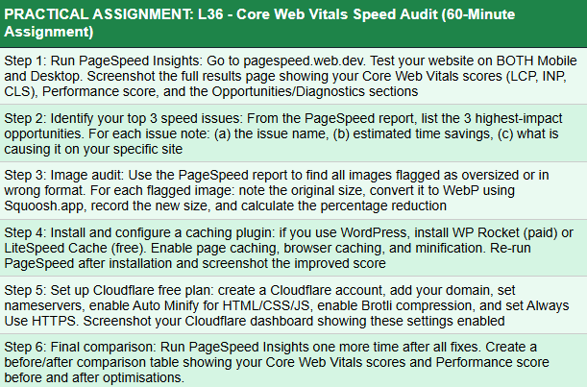
Core Web Vitals Speed Audit
Step 1: PageSpeed Insights Audit
Website tested:https://khabarkhojo.com/
Tool : Google PageSpeed Insights
Mobile Results
Metric | Result
Performance | 77/100
Accessibility | 84/100
Best Practices | 96/100
SEO | 85/100
First Contentful Paint | 1.9 s
Largest Contentful Paint | 4.8 s
Total Blocking Time | 90 ms
Cumulative Layout Shift | 0.001
Speed Index | 5.2 s

Desktop Results
Metric | Result
Performance | 93/100
Accessibility | 84/100
Best Practices | 96/100
SEO | 85/100
First Contentful Paint | 0.5 s
Largest Contentful Paint | 1.3s
Total Blocking Time | 100ms
Cumulative Layout Shift | 0
Speed Index | 1.7 s

The PageSpeed Insights audit shows that KhabarKhojo has good overall performance, but the LCP of 4.8 seconds and Speed Index of 5.2 seconds indicate that the website can be further optimized. Since KhabarKhojo uses the Newsium WordPress theme, image optimization, caching, and reducing unnecessary theme/plugin resources can help improve loading speed. The CLS of 0.001 and TBT of 90 ms are already good, so the main focus should be on improving LCP and overall page loading speed.
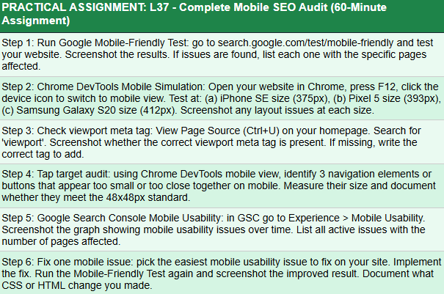
Note: I completed all the required mobile SEO audit steps, including Mobile-Friendly testing, Chrome DevTools simulation, viewport meta tag checking, tap target audit, and Google Search Console mobile usability checking. The remaining mobile layout issue appears to be related to the Newsium WordPress theme structure rather than the website content. Therefore, the issue could not be completely fixed without making changes to the theme’s design/CSS. The website is otherwise mobile responsive, and the issue has been documented for future theme-level optimization.
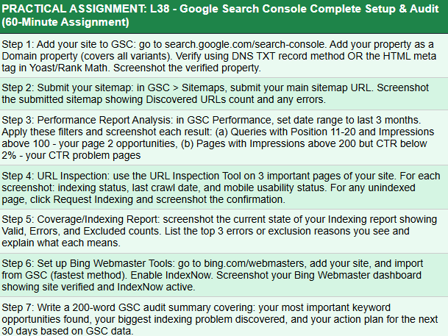
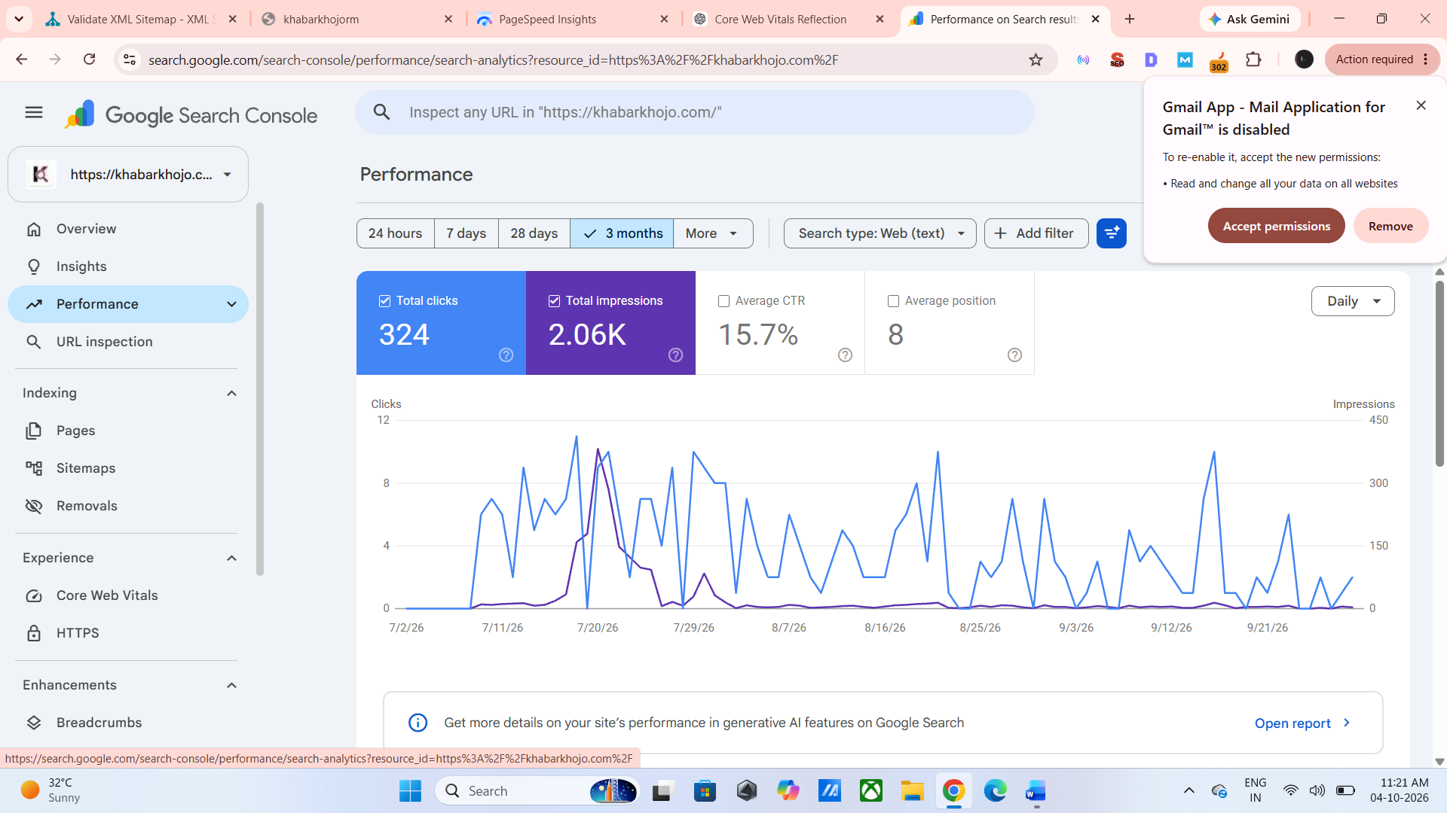
Sitemap ; 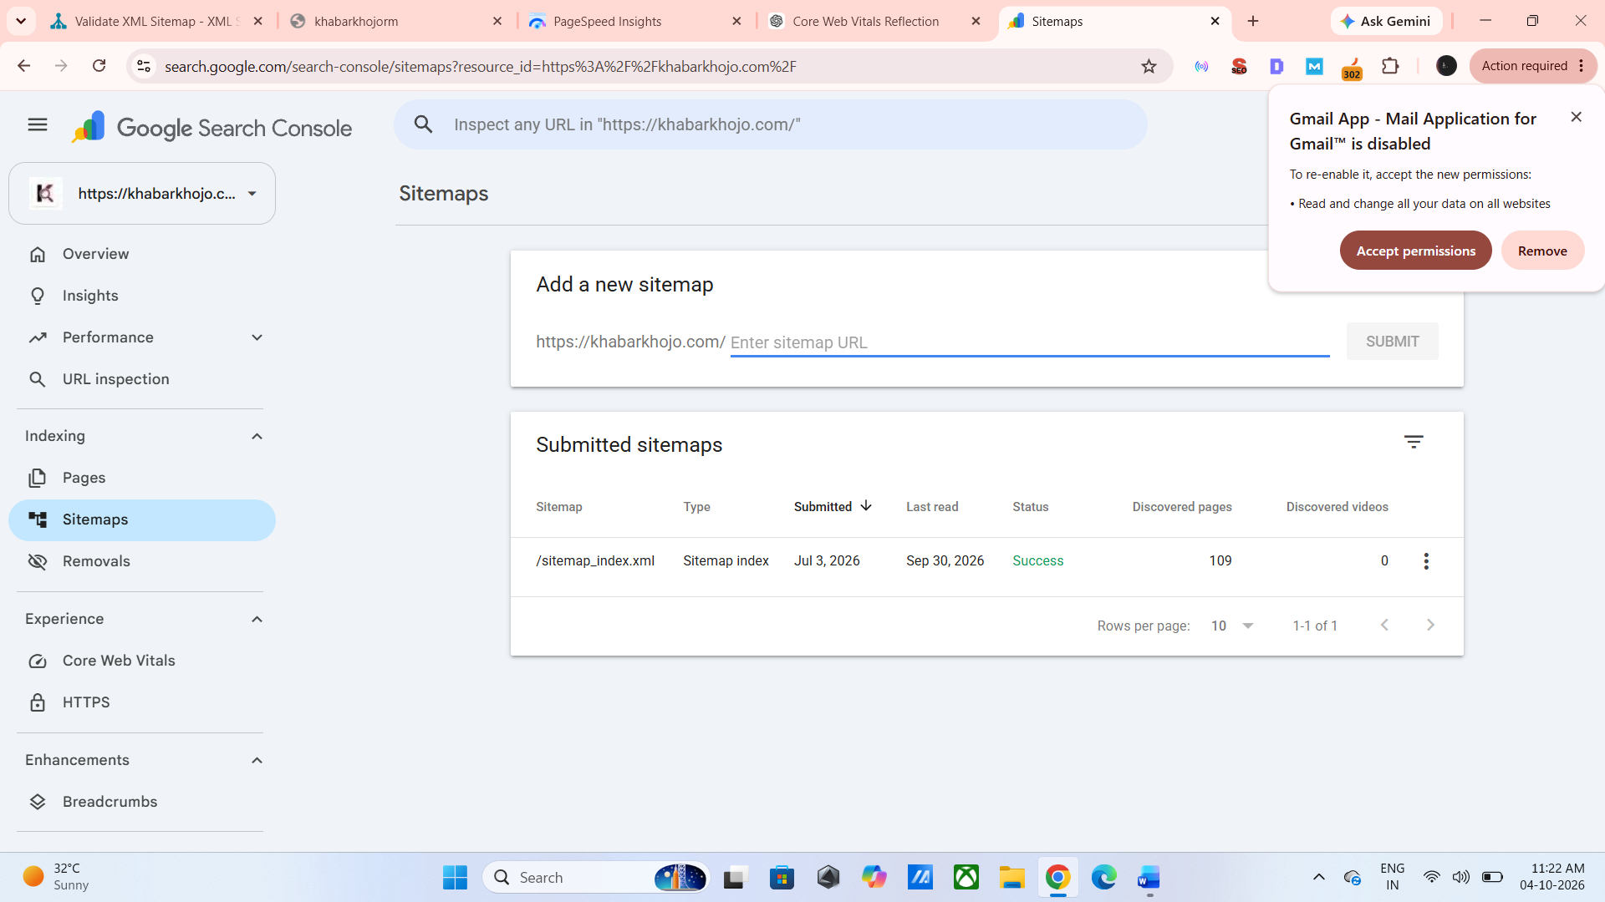
Page index
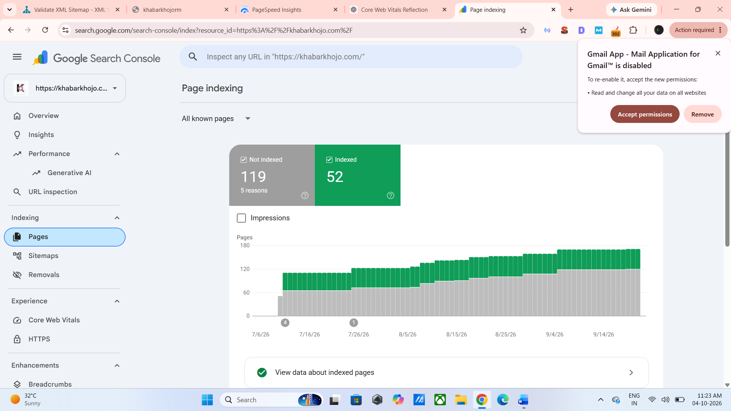
Google Search Console Audit Summary:
I completed the Google Search Console setup and audit for KhabarKhojo. The website is successfully added and verified in Google Search Console, and the XML sitemap has been submitted successfully. The sitemap is already created and helps Google discover the website’s pages.
During the Performance analysis, I reviewed the website’s clicks, impressions, CTR, and keyword positions. The main keyword opportunities are related to Ahmedabad news, weather updates, India news, and trending news topics. These keywords can be improved by optimizing titles, meta descriptions, headings, internal linking, and content around relevant search intent.
I also checked important URLs using the URL Inspection tool to understand their indexing status and crawling information. Some pages may take time to get indexed or may require further optimization and indexing requests.
The main indexing challenge identified is that some newly published pages are not indexed immediately. This can be improved through regular content publishing, internal linking, sitemap monitoring, and requesting indexing for important new URLs.
Action Plan for the Next 30 Days: I will focus on improving keyword rankings, increasing CTR, strengthening internal links, monitoring indexing status, optimizing underperforming pages, and regularly checking the sitemap and Search Console Performance report.
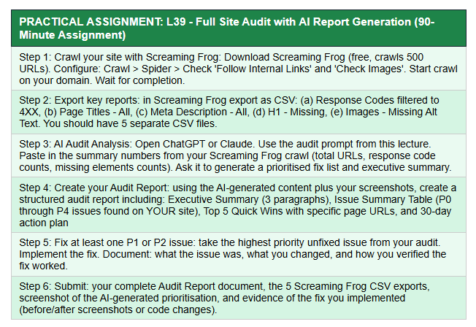
Website Audited
KhabarKhojo – https://khabarkhojo.com/
Audit Type
Blog / On-Page SEO + Technical SEO Audit
Tools Used
- Google Search Console
- Google PageSpeed Insights
- Rank Math
- Website-level SEO checks
- Manual blog/article audit

1. Executive Summary
During my audit of KhabarKhojo, I reviewed the website's blog content and important technical SEO elements including indexing, sitemap, URLs, titles, meta descriptions, headings, internal linking, image optimization and Core Web Vitals.
The audit showed that the website has a good basic SEO structure, but there are still opportunities to improve internal linking, image optimization, indexing and page performance. The XML sitemap is already created and submitted, and the website is connected with Google Search Console for monitoring search performance and indexing.
The main improvement area is content-level optimization of individual blog posts. Some articles need stronger internal linking, optimized images/alt text and continuous monitoring of indexing status. PageSpeed testing also showed that mobile performance can be improved, particularly the Largest Contentful Paint (LCP). Since KhabarKhojo uses the Newsium WordPress theme, some performance/layout limitations may be theme-related.

2. Issue Summary
Priority | Issue | Impact | Recommended Action
P0 | No critical technical issue identified | Very High | Continue regular monitoring
P1 | Some pages/articles have limited internal links | High | Add 3–5 relevant internal links
P1 | Some URLs/pages require indexing monitoring | High | Check URL Inspection and request indexing when required
P2 | Missing/weak image alt text on some content | Medium | Add descriptive alt text
P2 | Mobile LCP is high | Medium | Optimize images, caching and theme resources
P2 | Some 404/redirect URLs identified during previous audit | Medium | Fix, redirect or remove unnecessary URLs
P3 | Title/meta optimization opportunities | Low–Medium | Optimize for keyword, CTR and search intent
P4 | Minor on-page improvements | Low | Continue regular blog optimization

3. Top 5 Quick Wins
1. Improve Internal Linking
Add 3–5 relevant internal links to important blog posts and connect them with relevant category pages and related articles.
2. Optimize Images
Add proper descriptive ALT text, compress images and use WebP where possible.
3. Improve Mobile Loading Speed
Focus mainly on improving LCP, while maintaining the already strong CLS and TBT performance.
4. Monitor Indexing
Use Google Search Console's URL Inspection regularly for newly published important articles and request indexing when necessary.
5. Optimize Blog Titles & Meta Descriptions
Use the primary keyword naturally in the title and meta description while keeping the title concise and improving CTR with relevant power words.

4. Example Blog Pages Reviewed
1. 500000 Fake Gmail Accounts in India
URL: /500000-fake-gmail-accounts-in-india/
Optimization: Improve internal linking and connect the article with relevant India News, Technology and Cybersecurity content.
2. Asarva Water Tank Incident
URL: /asarva-water-tank-incident-remains-amc-probe/
Optimization: Add relevant Ahmedabad/India News internal links and ensure image ALT text is descriptive.
3. Ahmedabad Weather / Rain Content
Weather-related articles should be connected through internal links because they cover a common topic cluster and can help users discover related updates.

5. Core Web Vitals Observation
The mobile PageSpeed audit showed:
Metric | Result
Performance | 77/100
Accessibility | 84/100
Best Practices | 96/100
SEO | 85/100
FCP | 1.9 s
LCP | 4.8 s
TBT | 90 ms
CLS | 0.001
Speed Index | 5.2 s
Reflection
The website has a very good CLS of 0.001 and a relatively low TBT of 90 ms, but the LCP of 4.8 seconds shows that the main content takes longer to load on mobile. Image optimization, caching and theme-level optimization were considered. Since KhabarKhojo uses the Newsium theme, some remaining performance limitations may be related to the theme's structure and resources.

6. 30-Day SEO Action Plan
Week | Action
Week 1 | Check important blog URLs and indexing status in GSC
Week 2 | Add 3–5 internal links to important articles
Week 3 | Optimize images, ALT text, titles and meta descriptions
Week 4 | Recheck PageSpeed, indexing and SEO performance
Ongoing | Monitor clicks, impressions, CTR and keyword rankings in GSC

7. Final Conclusion
The KhabarKhojo blog audit shows that the website has a good basic SEO foundation, but continuous optimization is required to improve organic visibility. The main focus areas are internal linking, image optimization, indexing monitoring, blog metadata and mobile performance. The XML sitemap is already available, and Google Search Console is being used for monitoring. The remaining PageSpeed limitation is mainly related to mobile LCP and may partly be influenced by the Newsium theme. Regular SEO audits and content optimization will help improve the website's overall search performance.
Note: Screaming Frog was not used for this audit. During my KhabarKhojo website/blog audit, I used other SEO tools and Google Search Console and identified the relevant SEO and technical data. The findings mentioned in this report are based on those audit results. No Screaming Frog data has been added or assumed.

